The website I choose is http://www.barlouie.com/menu# below are the two views of website. 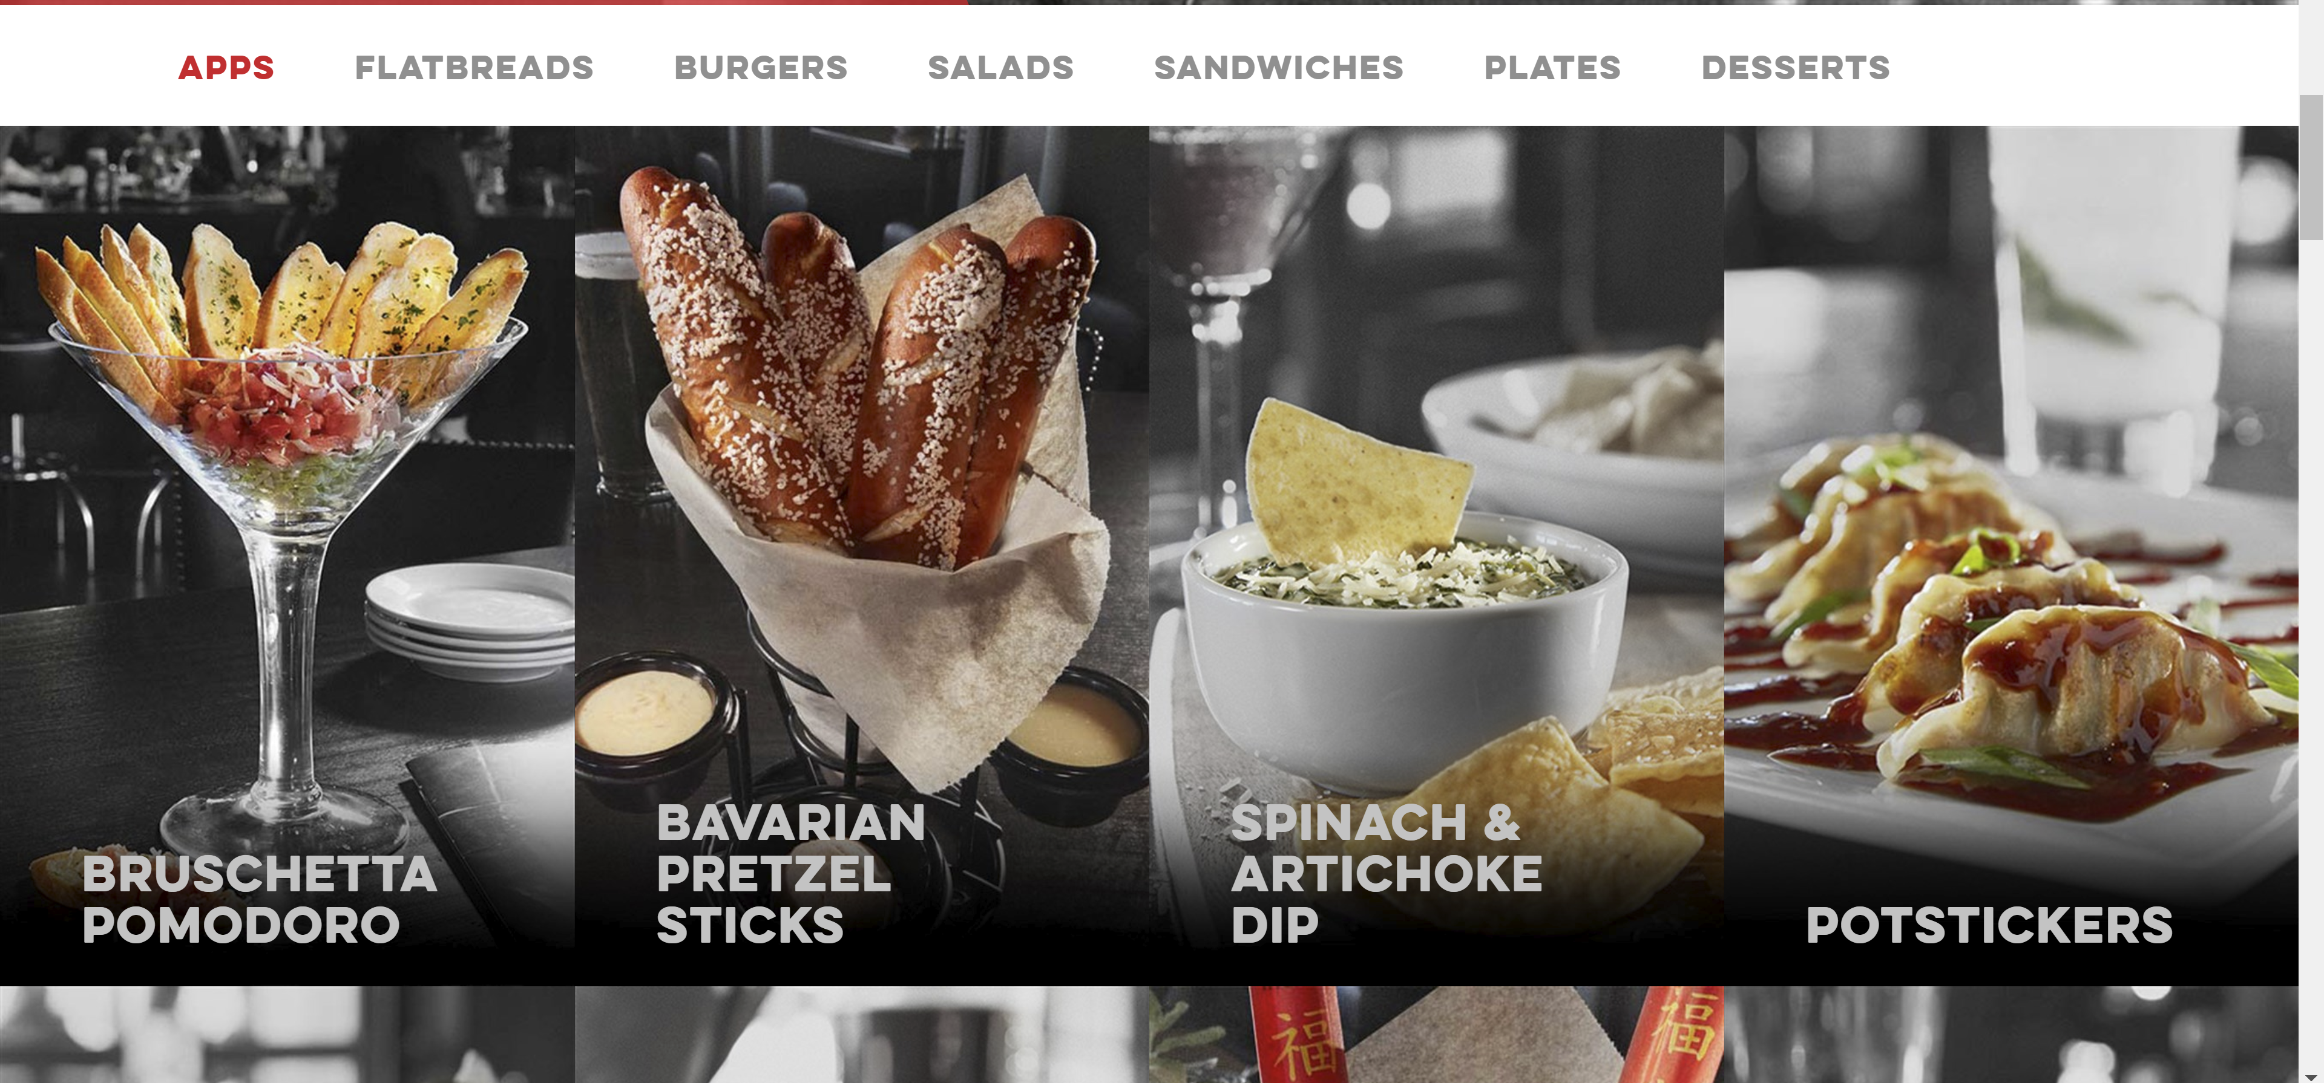

Desktop View of the Menu

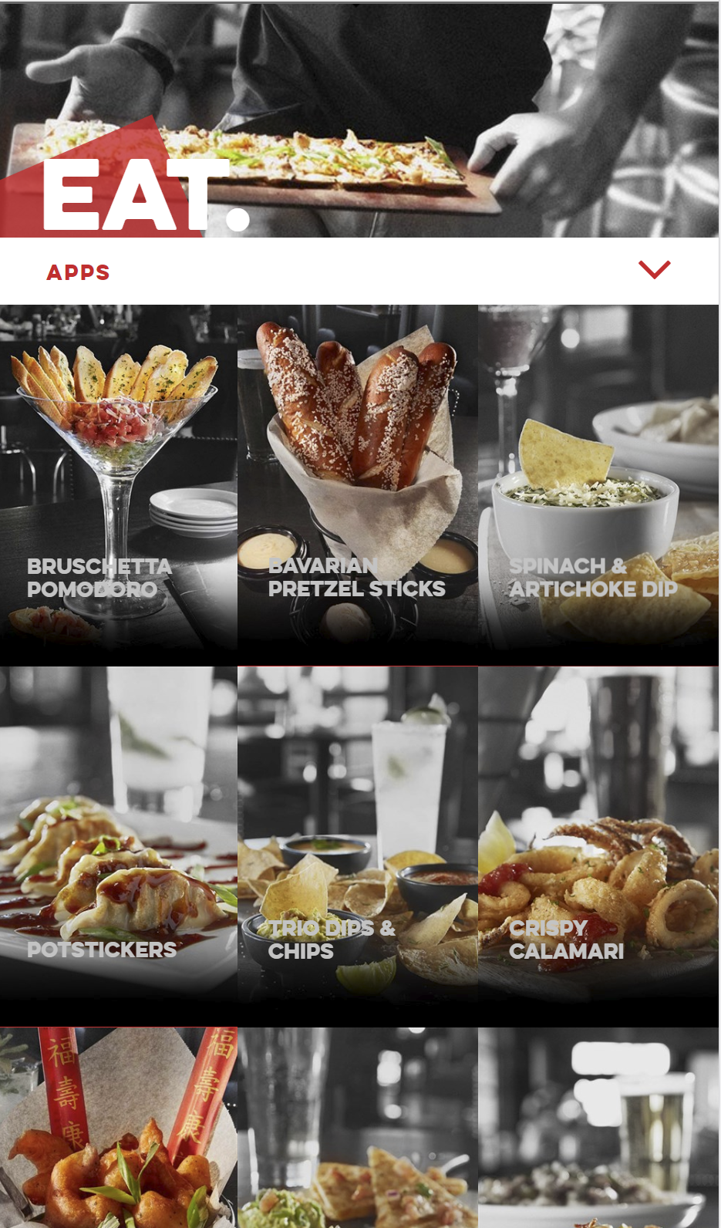 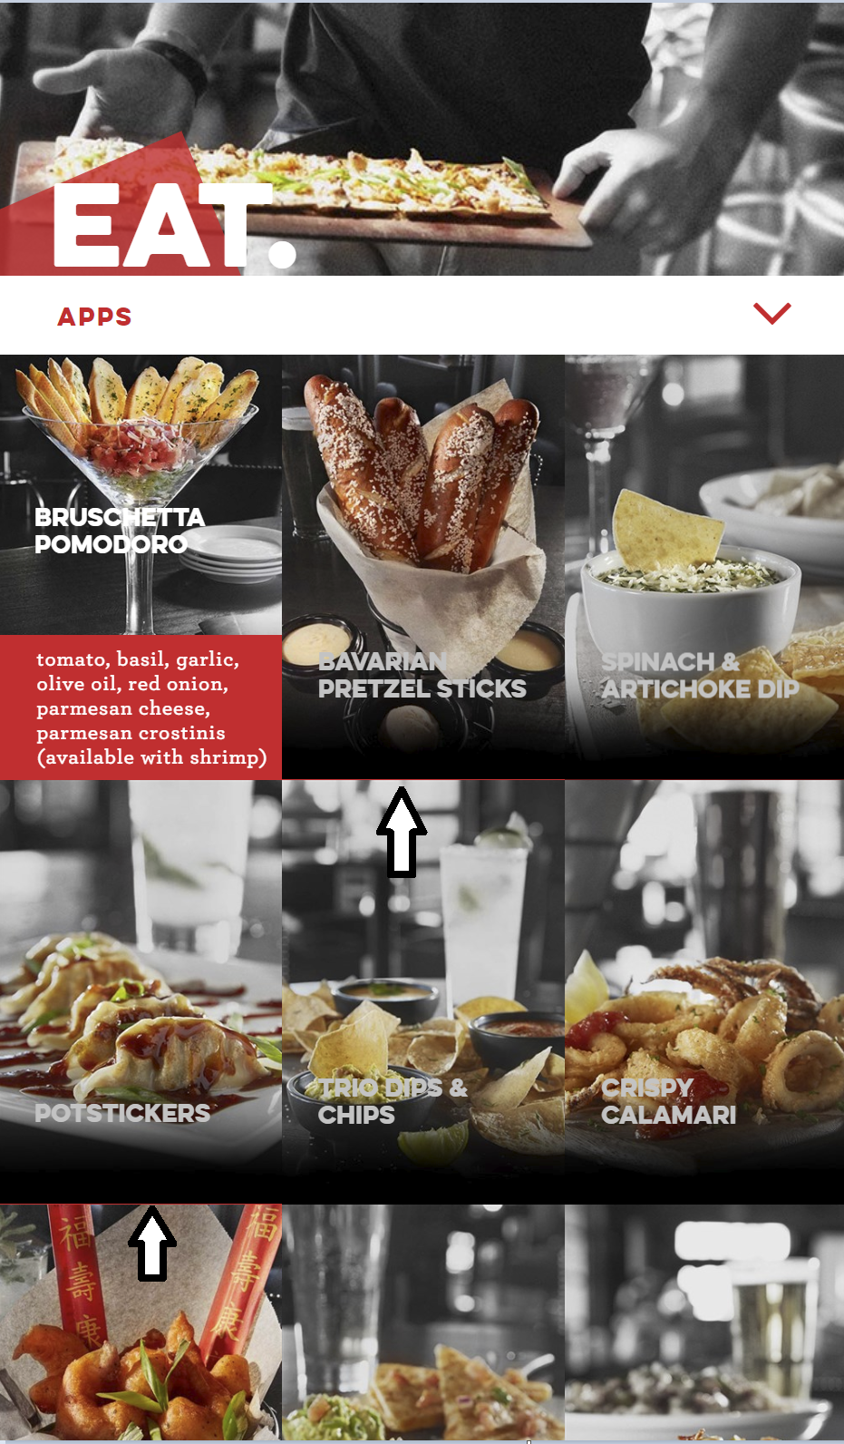

Mobile View of the Menu

The minor improvement to the website seen above is the way it displays its menu. The problem is that in the mobile version the user can click on the item to see the ingredients of the item. However, in the desktop version this is a problem, the on click feature does not work. The display on the mobile view has random red lines appearing, this may distract the user. The arrows on the last image show where the random red lines are located.

The fix to this problem is to organize the desktop version. I would suggest using borders between each image, so it is easier for the users eyes to navigate the page. Also, I would improve the JavaScript to allow for a click to view all the ingredients/description of the menu item. In the mobile, I would also put the border between the images, this may also help with solving the random red lines showing up.

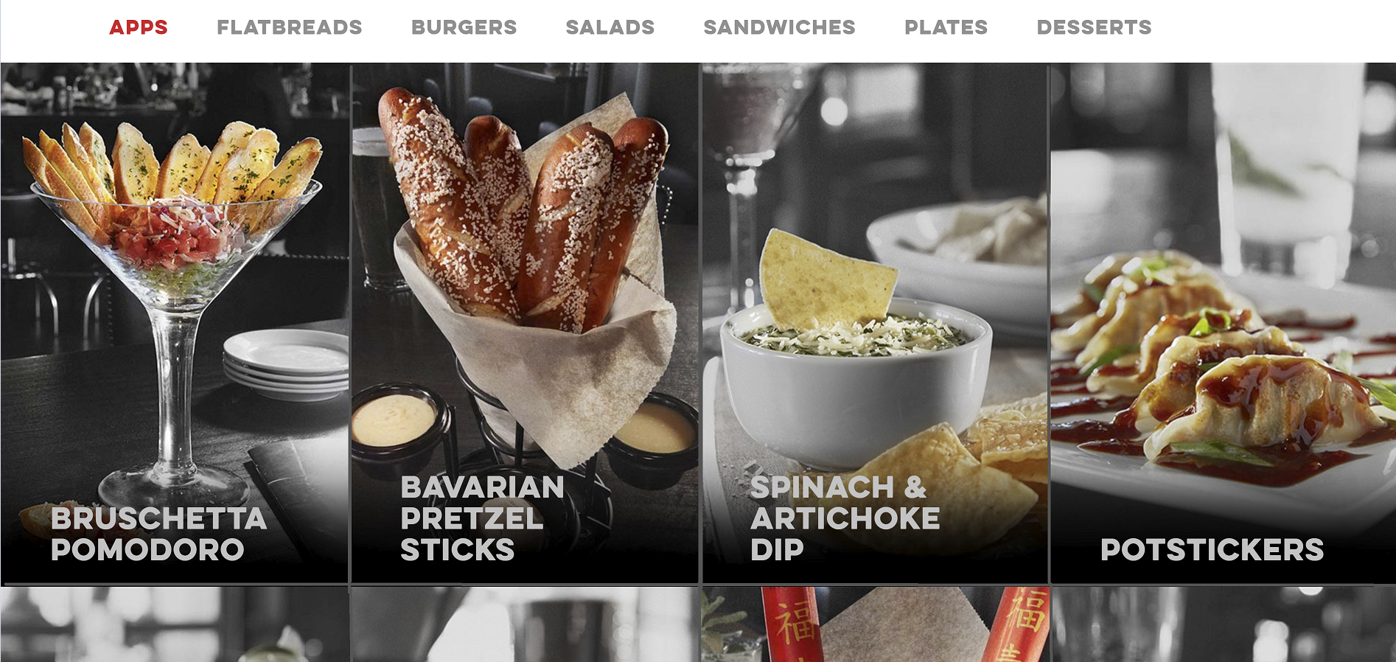

**Improved Desktop View:**

1. Putting simple borders between each image is more appealing to the eye. It makes it cleaner. This would be a change in the CSS for inputting borders onto the images.

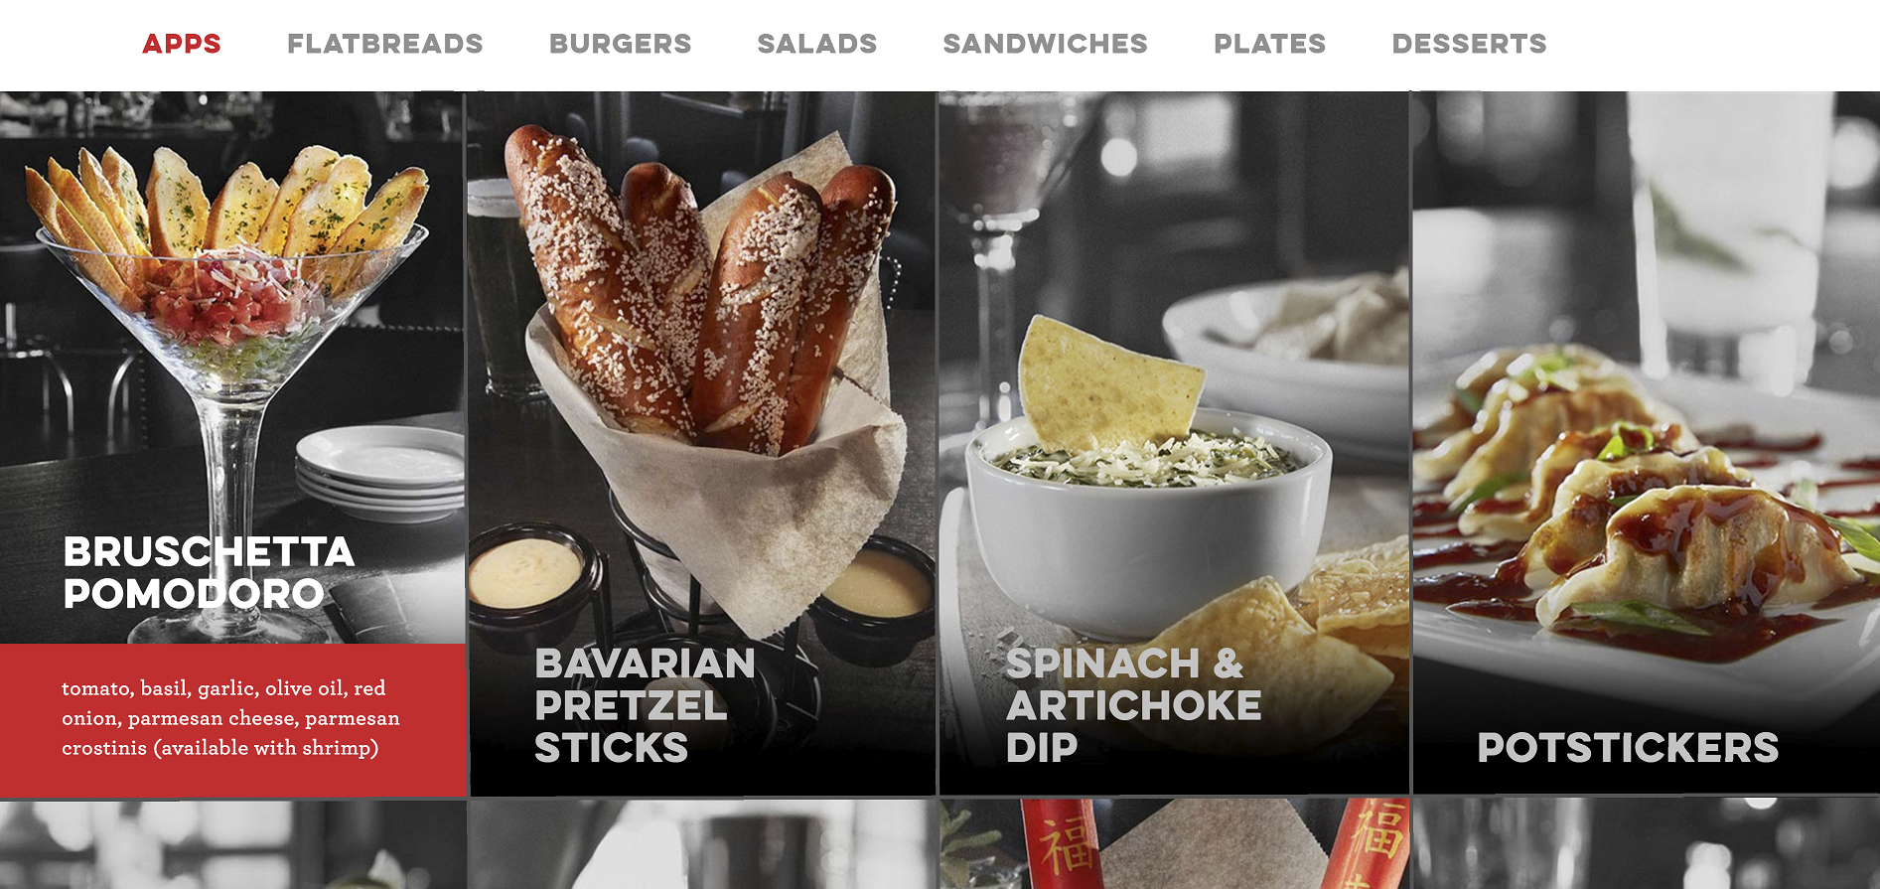

2. Adding JavaScript to each image, when clicked on it shows the ingredients for each item in the menu. The code is already used in the mobile version, the only thing is to insert it on the desktop view as well.

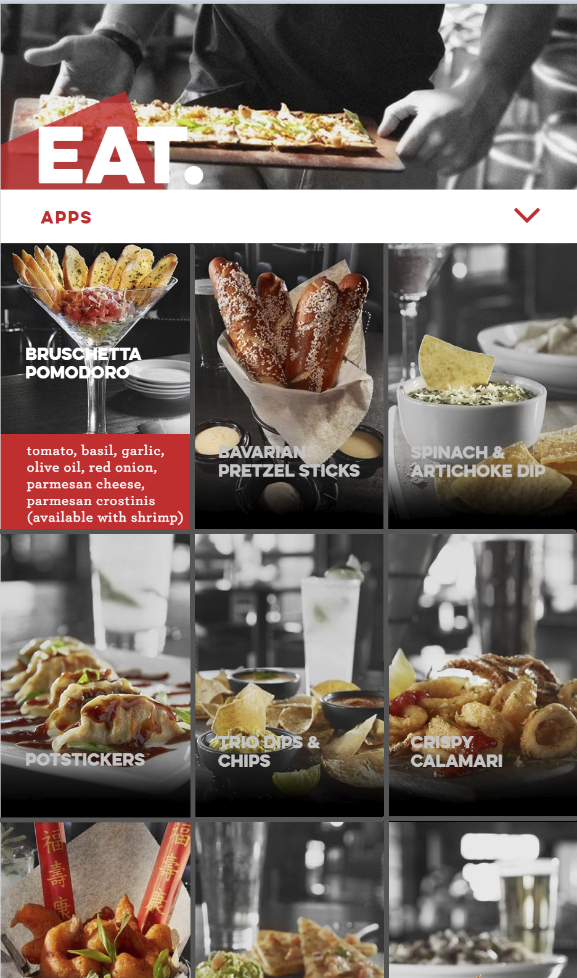

**Improved Mobile View:**

3. On the above image, I just inserted the borders just like the desktop version. This is done solely in the CSS using border in the media query, and you can select which sides to color in. This helps with the random red lines appearing on the page as well. It makes it look cleaner and pleasing to the eye as well.